Student Employment

How to find a job on campus
Muskingum uses the Handshake app to manage campus employment opportunities.
To Search MU’s on campus student employment jobs:
- Go to joinhandshake.com.
- Use your MU email address to login.
- Click on Jobs on the side navigation bar.
- In the top search bar, type Muskingum University.
- Click on the Job Title to learn more about the job/department and any qualifications needed.
- Click the green Apply button when ready to apply (you will need to have a resume uploaded to your profile).
Need a resume? Upload your current resume in Handshake under your Documents or click on Career/Center Resources to access a resume template. Need help? Contact the Impact Center at impactcenter@muskingum.edu.
What you need to do before you can work on campus
- Visit the Human Resources Office (Montgomery Hall 16).
  - You will be asked to provide original identification documents to fill out a Federal I-9 form.
  - The most used forms of identification are:
    - US passport OR
    - A photo ID AND a Social Security Card OR
    - A photo ID AND a Birth Certificate
- Once all the required documents have been completed you will receive an email from Human Resources with a Certificate of Work Authorization.
For more information about the student employment process please visit:
muskingum.edu/human-resources/student-employment
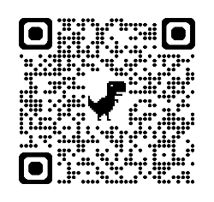
Connect to Handshake
Here

